QMS SURVEY FUNCTIONAL SPECIFICATION

Project Title: | QMS_Replacement
Project ID: | 3745
Business Analyst: | Sharon Makgato
Project Manager: | Mamokhele Tlemo
Technical Lead: | Zwelethu Dlamini
Project Sponsor: | Busiku Muleya

Document prepared by: | Sharon Makgato
Version No: | V1.0

Document Review and Distribution

This document will be managed and controlled in terms of the Airports Company South Africa IT Project Management Office document management procedure.

Revision history
Version | Author | Date | Revision
V0.1 | Sharon Makgato | 15 September 2017 | Initial Draft
V1.0 | Sharon Makgato | 30 October 2017 | Final Draft

This document has been reviewed by
Reviewer | Position | Date reviewed | Comments | Signature
Thabang Khoetha | Customer Experience Officer | 18 September 2017

This document has been distributed to
Name | Title | Date

GLOSSARY

Item | Description
QMS | Quality Management System which is used by ACSA to conduct quality audits, Stakeholder Surveys and the reporting thereof.
Stakeholder | A person or business with an interest or concern in ACSA business.
Stakeholder Feedback Survey | A questionnaire which is sent to business partners for them to rate their satisfaction levels provided to them by ACSA.
Stakeholder Survey Participants | Any stakeholder that is involved in direct interaction with the passenger, airport as well as cargo processes
Survey | A questionnaire that is sent to stakeholders to evaluate ACSA services.

TABLE OF CONTENTS

1 Project Background 5
2 Solution Overview 6
2.1 User Management Module 7
2.2 Reporting Module 7
2.3 Schedule Management Module 8
2.4 Audit Module 8
2.5 Survey Module 8
2.6 Use Case Diagram 9
2.7 Document Scope 9
3 Stakeholder Survey Process 10
4 Interface Design – Frontend 11
4.1. Survey Questions Screens 11
4.2. Reports 15
5 Integration Requirements 15
7. Appendix: Approval 16

Project Background

Airports Company South Africa (ACSA) uses Quality Management System (QMS) to conduct for quality audits and stakeholder surveys.

The System is currently hosted externally, and ACSA has limited control over the system; and it is not aligned with the current operating model. The contract with the Service Provider will lapse in July 2018. The system has been in the environment for a number of years. Through the years ACSA requirements in terms of quality assessments, audits and reporting has changed.

An assessment was done for QMS during the period of August to October 2016. The following were the findings
- Though the system supports ACSA’s quality objectives, there is some improvements that needs to be done.
- ACSA operating model has changed and with the new structure in place, the AS IS QMS requires some major changes to support the operational requirements.
- In consultation with the Service Provider, the indication was that it will take a period of about a year to cater for the changes, the time period proposed by the Service Provider happens to coincide with the contract end date, and as a result a decision was taken to develop and host QMS internally so that ACSA can have full control of the system.

The purpose of this document is to capture the functional requirements for QMS to ensure continuity when the contract lapses in July 2018.

Solution Overview

The illustration provides an overview of all the modules required for QMS. A user will be required to register onto the system (User management). The Manager or Customer Experience Officer will then schedule the audits or surveys to the relevant auditor/agent (Schedule Management Module). The user will then login, once registered, and have access to all audits assigned and complete the respective audits(Audit Module) or surveys (Survey module). Once the audits or surveys are complete, reporting information will be made available via the (Reporting Module).

Figure 1: Solution Overview

2.1 User Management Module
The User Management Module is role based and manages the registration of
users onto the system. All users registered on the system will be assigned a role. The login details will determine which audits should be visible to the logged in user as well as the completion date. There are five (5) types of user rights defined. A user may have more than one ‘user right’ enabled.

User Right | Description | Modules
Agents | Users who will complete audits on the system | User Management (frontend),  Audit Module
Manager | Users who will capture assessments on the system, as per the defined schedule | User Management (frontend),  Schedule Management Module
Report viewer | User is only allowed to view reports in the system | User Management (frontend),  Reporting Module
Customer Experience Officer | Administrator responsible for Stakeholder Surveys Reports | User Management (frontend)  Reporting Module
Research and Quality Management Official | User will Administer audits and  Extracts reports | User Management (frontend),  Survey Module
Administrator | Administers the system, approves the user registration process | User Management (backend),

2.2 Reporting Module
The Reporting Module provides access to all the reports defined within the system. There
are various types of reports defined such as: (i) Survey reports sent out after each
survey done via email to the relevant account managers, (ii) Dashboard Reports which provide a consolidated overview of information and (iii) user defined reports with drill down capability. Including, reports per site and at Group level.

2.3 Schedule Management Module
The Schedule Management Module manages the scheduling of all assessments, per
user. The scheduler will gather the following from each of the airports, per assessment:
- Audit Name or Survey Name
- Frequency: daily, monthly, weekly, biweekly, bimonthly
- Due Date of audit or survey
- User assigned to assessment
- User role

2.4 Audit Module
The Audit Module will allow the user access to all the audits they have scheduled or are scheduled for. The Audit Module will allow the following:
- Provide mandatory comments for ‘non-compliant’ answers
- Capture pictures (optional)
- On completion of an assessment, an email will be sent to the capturer and predefined distribution list containing (i) summary of non-compliant answers in email body and (ii) completed report in .pdf attachment.

2.5 Survey Module
The Survey Module will allow the user access to send out surveys to the relevant stakeholder. The module will also facilitate the upload of surveys completed by stakeholders and the processing thereof.
The Stakeholder surveys are sent to stakeholders through a link that include the following areas:
- Environment;
- Facilities;
- Productivity and people; and
- Technology and equipment.

The Stakeholder categorized under the following environments:
- Airlines;
- Car Rentals;
- Retailers;
- Restaurants;
- Ground Handlers;
- Government Agencies;
- Security;
- Property;
- Cleaning; Maintenance and Engineering; and
- Banks and Bureaus.

2.6 Use Case Diagram
Figure below is the use case diagram that shows how actors interact with the QMS and what their actions are.
Figure 2: Use Case Diagram

2.7 Document Scope

This Functional Specification document covers the survey module of QMS. Audit and reporting modules will be documented separately.

Stakeholder Survey Process

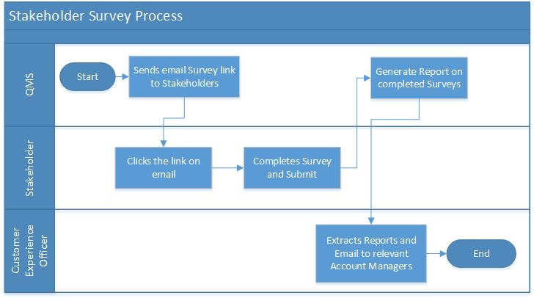

Applicable Business Rules

- A Stakeholder should receive a survey only one month in a quarter
- The survey is a quarterly survey and groups stakeholders within the three months in the quarter.
- The survey should be sent electronically 7th of every month to selected group of stakeholders
- Survey runs from the 7th day of the month to the 6th day of the month
- The system should track and monitor stakeholders who have not completed the survey and sends them reminders on weekly basis.
- Record the stakeholders completed and non-completed in raw-data report
- Include schedule and end dates in the raw data report.
- The system should track all undelivered surveys and immediately send a report back in order to correct/update the email address.

Interface Design – Frontend

4.1. Survey Questions Screens

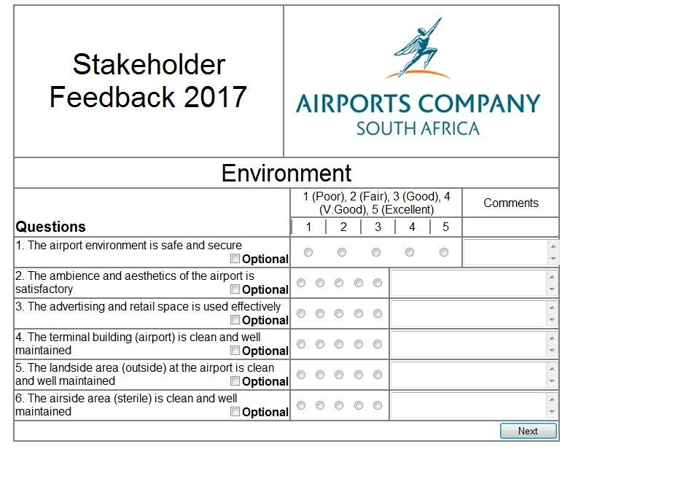
Environment | The advertising and retail space is used effectively
 | The airport environment is safe and secure
 | The airside area (sterile) is clean and well maintained
 | The ambience and aesthetics of the airport is satisfactory
 | The landside area (outside) at the airport is clean and well maintained
 | The terminal building (airport) is clean and well maintained

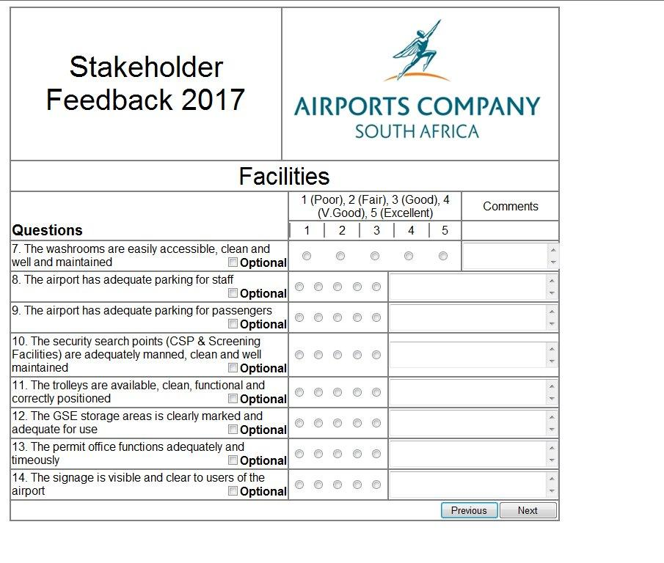
Facilities | The airport has adequate parking for passengers
 | The airport has adequate parking for staff
 | The Ground Service Equipment storage areas is clearly marked and adequate for use
 | The permit office functions adequately and timeously
 | The security search points (Central Screening Point & Screening Facilities) are adequately manned, clean and well maintained
 | The signage is visible and clear to users of the airport
 | The trolleys are available, clean, functional and correctly positioned
 | The washrooms are easily accessible, clean and well and maintained

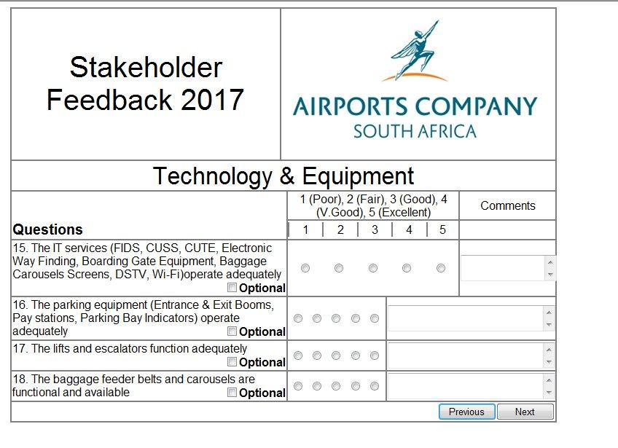
Technology and Equipment | The baggage feeder belts and carousels are functional and available
 | The IT services (Flight Information Display Screens (FIDS), CUSS, CUTE, Electronic Way Finding, Boarding Gate Equipment, Baggage Carousels Screens, DSTV, Wi-Fi) operate adequately
 | The lifts and escalators function adequately
 | The parking equipment (Entrance & Exit Booms, Pay stations, Parking Bay Indicators) operate adequately

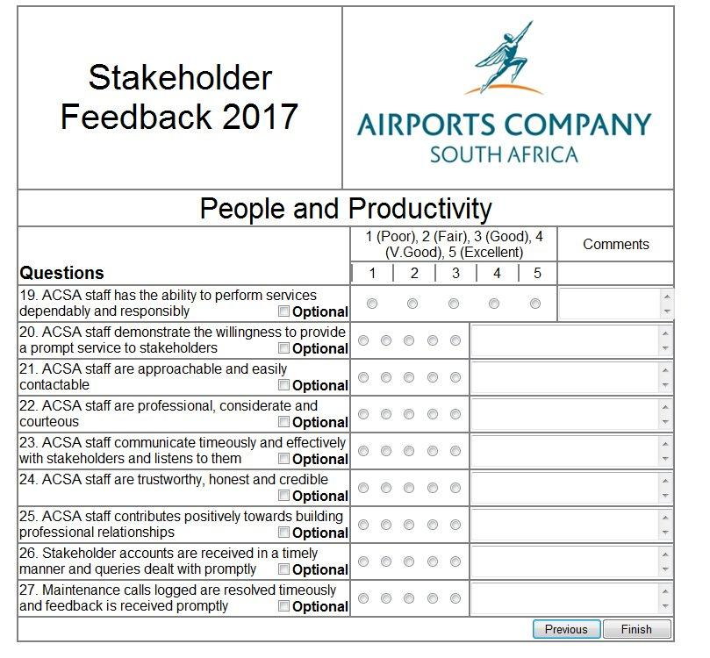
People and Productivity | ACSA staff are approachable and easily contactable
 | ACSA staff are professional, considerate and courteous
 | ACSA staff are trustworthy, honest and credible
 | ACSA staff communicate timeously and effectively with stakeholders and listens to them
 | ACSA staff contributes positively towards building professional relationships
 | ACSA staff demonstrate the willingness to provide a prompt service to stakeholders
 | ACSA staff has the ability to perform services dependably and responsibly
 | Maintenance calls logged are resolved timeously and feedback is received promptly
 | Stakeholder accounts are received in a timely manner and queries dealt with promptly

4.2. Reports

The following reports are generated from Stakeholder surveys conducted:
- Raw data report
- Monthly value chains
- Quarterly value chains
- Departmental pulse reports
- Completion rate report
- Executive summary report

Extract Stakeholder survey screens are in scope for QMS Reporting Functional Specification.

Integration Requirements

Stakeholder Survey raw data should be accessible from the QlickView system for Business Intelligence Reporting.

7. Appendix: Approval
QMS Business Owner
Busiku Muleya | Signature: | Date:
QMS Functional Lead
Tumelo Nkwane | Signature: | Date:
QMS Surveys Specialist
Thabang Khoetha | Signature: | Date:
Business Analyst
Sharon Makgato | Signature: | Date:
Project Manager
Mamokhele Tlemo

Technical Lead
Zwelethu Dlamini | Signature: | Date:
IT Applications Senior Manager
Seoka Nkunyane | Signature: | Date:

